**抑郁问卷的异质性：基于对27个抑郁测量问卷的内容分析**

汪浩远1, 胡孟真1, 田柳青1, 刘伟彪1, 安媛媛1, 李瑛2, 胡传鹏1#

(1南京师范大学心理学院; 2首都医科大学附属北京儿童医院精神科)

**Assessing the heterogeneity of 27 scales for measuring depression**

Haoyuan Wang, Mengzhen Hu, XXX

**CrediT Author Statement**

**Wang Hao Yuan：**Conceptualization, Data curation, Investigation, Writing - Original Draft. **Hu Meng Zhen：**Data curation, Visualization, Investigation. **Tian Liu Qing:** Investigation. **Liu Wei Biao:** Investigation. **Yuanyuan An:** Writing- Reviewing and Editing. **Ying Li:** Writing- Reviewing and Editing. **Hu Chuan-Peng：**Supervision**,** Project administration, Writing- Reviewing and Editing.

Corresponding author: Hu Chuan-Peng, email: hcp4715@hotmail.com

JAMA Network Open

Asian Journal of Psychiatry

看看编辑投稿风格

摘要

关键词

# 1. 引言

按照总分总方式写主旨句

[第一段的主旨句]

抑郁障碍的严重性（患病率、社会成本等），青少年期和成年早期是关键的时间。

[第二段的主旨句]

自评量表在抑郁症的研究中广泛使用，也是各类关于青少年与学生政策的基础（中国、世界范围内大规范调查的的数据）

[第三段的主旨句]

但抑郁自评量表数量繁多，被广泛使用的量表也不在少数，有潜在的重大影响（如影响到心理健康问题的检出率）。

[第四段的主旨句]

当前研究发现不同抑郁问题可能在测量不同的内容。Fried（2017年）的研究表明，不同的抑郁量表不能互相替代使用，这给抑郁研究带来了挑战。

[第五段的主旨句]

上述问题可能也延伸到发展中国家，但目前没有实证的数据进行评估，本研究将对用于学生的抑郁自评量表进行分析。

还可以补充一些非常广泛的调查，只用了某一个问卷。可以用大规模调查用的问卷来举例。例如中国国民心理健康发展报告，心理所的调查只用了ces-d简版和中国心理健康量表简版广泛焦虑。

# 2. Methods

We took three steps to extract symptoms from all scales that measure depressions among students population (see Fig 1 for the flowchart). Firstly, we identified all scales that has been used for screening depression among students and screen the scales for completedness of their items information. Secondly, we identified unique symptoms of each scale. Thirdly, we compared the symptoms between different scales. The latter two steps followed Fried (2017) but with modifications (see details below).

## 2.1 Identify and screen scales

We identified scales that measure depression from four recent meta-analyses which synthesized the prevalence of different mental health problems among four students populations: elementary school, middle school, high school, and college (于晓琪等, 2022; 黄潇潇等, 2022; 张亚利等, 2022; 陈雨濛等, 2022). We extracted all papers included in these meta-analyses and selected scales that were used for screening depression. In total, we identified 34 scales from 470 articles included in these four meta-analysis.

We then evaluated multiple versions of scales (if exist) and identified the most valid version for later analysis. The rationale behind this examination lies in the fact that even for the same scale, meta-analytic data may provide multiple versions. When confronted with multiple versions of a scale, we adhered to the following inclusion criteria: (1) If the scales cited in the meta-analytic data are available only in English, we search for the Chinese versions ourselves; (2) If the citations in the meta-analytic data provide both English and Chinese versions, we prioritize selecting the Chinese version ; (3) If a scale has one version with and the other version without symptom names, we favored the version including symptom names; (4) When all other factors were equivalent, our choice leaned towards the most widely cited version. For instance, CES-D was first translated by 汪向东等(1999), which was used by 39/470 papers. However, 章婕等(2010) revised the 20th item, "I could not get going", of this scale because the meaning of original translation, “我走路很慢” ("I walk very slowly" as directly back translated into English), diverge from the original English meaning. Instead, 章婕等(2010) translated this item as “我提不起劲儿来做事” ("I lack the motivation to do things" as directly back translated into English). Thus we chose the revised version by 章婕等(2010).

## 2.2 Identify symptoms within scales

In this phase of our study, four trained coders focused on identifying items that assessed identical or similar symptoms within each scale. The process proceeded as follows: First, the four coders independently identified and consolidated items within each scale. Then, they formed two pairs, with each pair reviewing their results and resolving any discrepancies. Subsequently, the two pairs of coders cross-checked their findings and collaboratively addressed any remaining inconsistencies, seeking guidance from the corresponding author when necessary. The final, consolidated version of the results underwent independent verification by a clinically certified doctor (co-author ***), who made necessary revisions to ensure accuracy.

## 2.3 Compare symptoms across different scales

In this step, the same four coders compared symptoms across all scales. The procedure was the same as the identification of symptoms within scales: indepenedent individual coding, discussion by pairs, cross-checking between pairs, discussion with the corresponding author, and verification by a clinically certificated doctor.

The coding processes were as follow. We first pooled symptoms from all scales together and identified unique symptoms. In this step, we retained both compound symptoms and specific symptoms, as in Fried (2017). Compound symptoms are symptoms that include a range of related symptoms, whereas specific symptoms are more concrete and describe specific patterns. For example, “appetite changes” is a compound symptom, it includes two specific symptoms: “appetite increased” and “appetite decreased”. And all three symptoms were treated as unique symptoms. We employed an approach that maximize the amount of different symptoms. More specifically, if the items describe similar symptom using different words and that the words have significantly different meanings under the Chinese context, we treat them as belonging to the same compound symptom but are different specific symptoms. For instance, there are many different words for describe depressed mood in different scales, we used 'depressed moods' as the compound symptom but distinguish different specific symptoms such as: 'blue', 'low mood', 'sad', and 'anhedonia'. This approach is slightly different from Fried (2017), where he coded all these item as a specific symptom 'Sad moods'.

Then, we coded each scale on all unique symptoms. More specifically, a scale was coded as “0” on a symtom if it does not have items that measures this symptom. If a scale has an item that directly measures a symptom, compound or specific, it was coded as 2 on that symptom. Note if a scale has an item measures a compound symptom, then, this scale not only had a score of 2 on that compound symptom but also has a score of 1 on each of the specific symptoms under this compound symptom. For instance, the CDI has no item for 'Depressed mood' , we assigned “0” for CDI on this symptom. For compound symptom “appetite change”, CDI has an item directly measures this symptom and was coded as 2 on this symptom. Importantly, even CDI does not have item for specific symptoms of “appetite changes”, i.e., 'appetite increased' and 'appetite decreased', it was coded as 1 on both two specific symptoms (see Supplementary Materials and Figure 2 for details). However, if the item measures a specific symptom under a compound symptom, this scale was coded “2” on that specific symptom but also coded as “0” on the corresponding compound symptom.

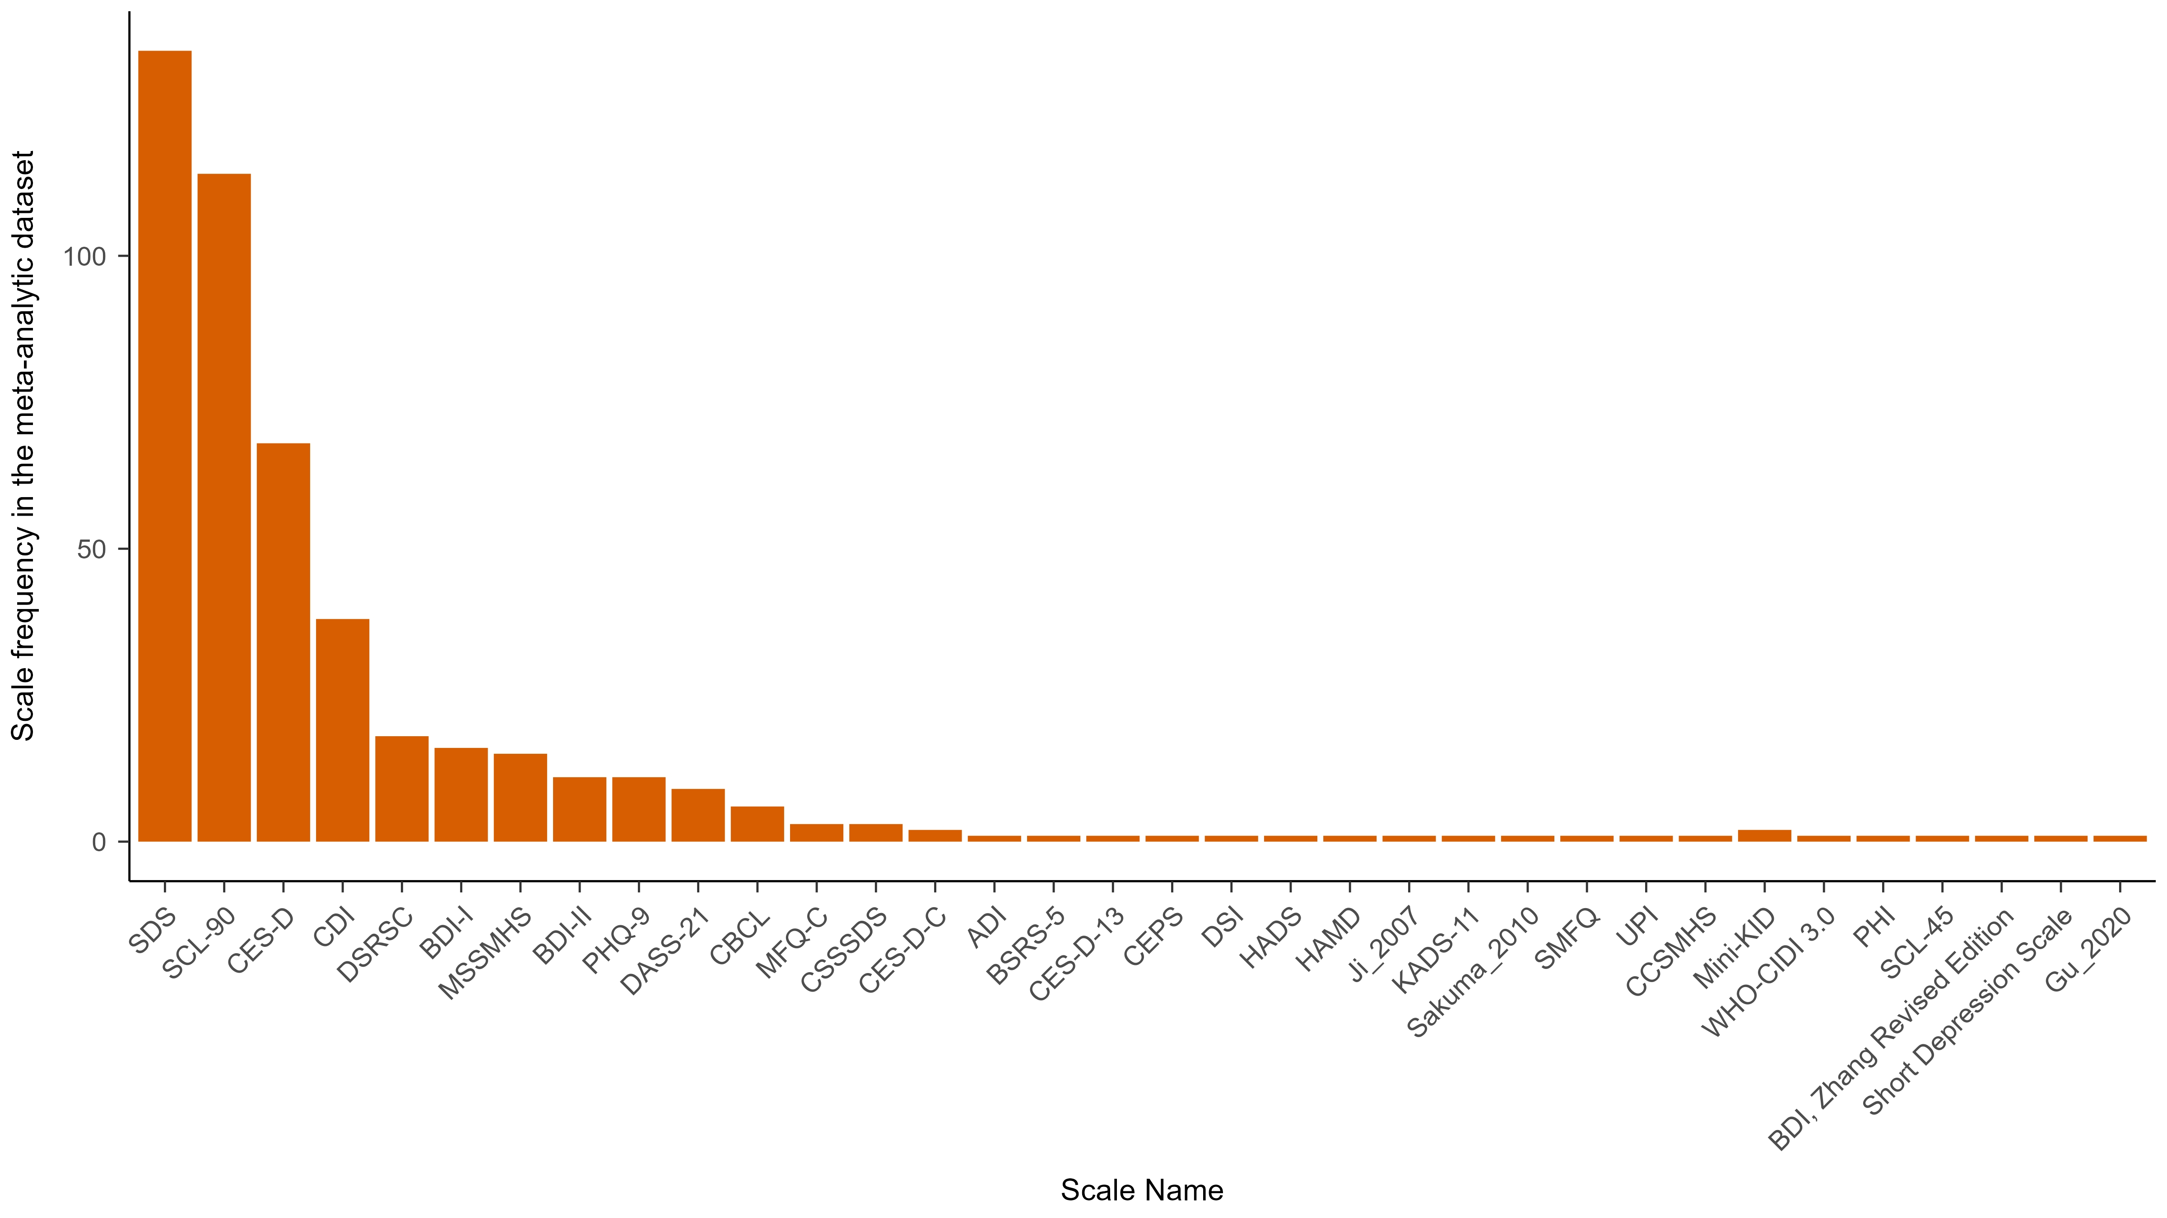

**Figure 2**

*Number of articles that used each scale for screening depression.* Total number of articles were based on those included in four meta-analyses (XXX). Scales with * were excluded from our analyses.

## 2.4 Data analyses

We reported the following information: descriptive details of different symptoms and the performance and characteristics of scales on various symptoms. Additionally, we provided the proportions of idiosyncratic symptoms (symptoms appeared in only one scale), the respective proportions of compound and specific symptoms, and the proportions of DSM-5 depressive symptoms included.

We used Jaccard index for the degree of overlap between different scales (Fried, 2017). The formal of Jaccard index is s/(u1 + u2 + s), where "s" represents the number of items shared by two scales, and "u1" and "u2" denote the number of items that are exclusively present in each of the two scales. Jaccard index ranges from 0 (no overlap among scales) to 1 (complete overlap). We interpreted Jaccard index as in Fried (2017) guidelines: very weak 0.00–0.19, weak 0.20–0.39, moderate 0.40–0.59, strong 0.60–0.79, and very strong 0.80–1.0.

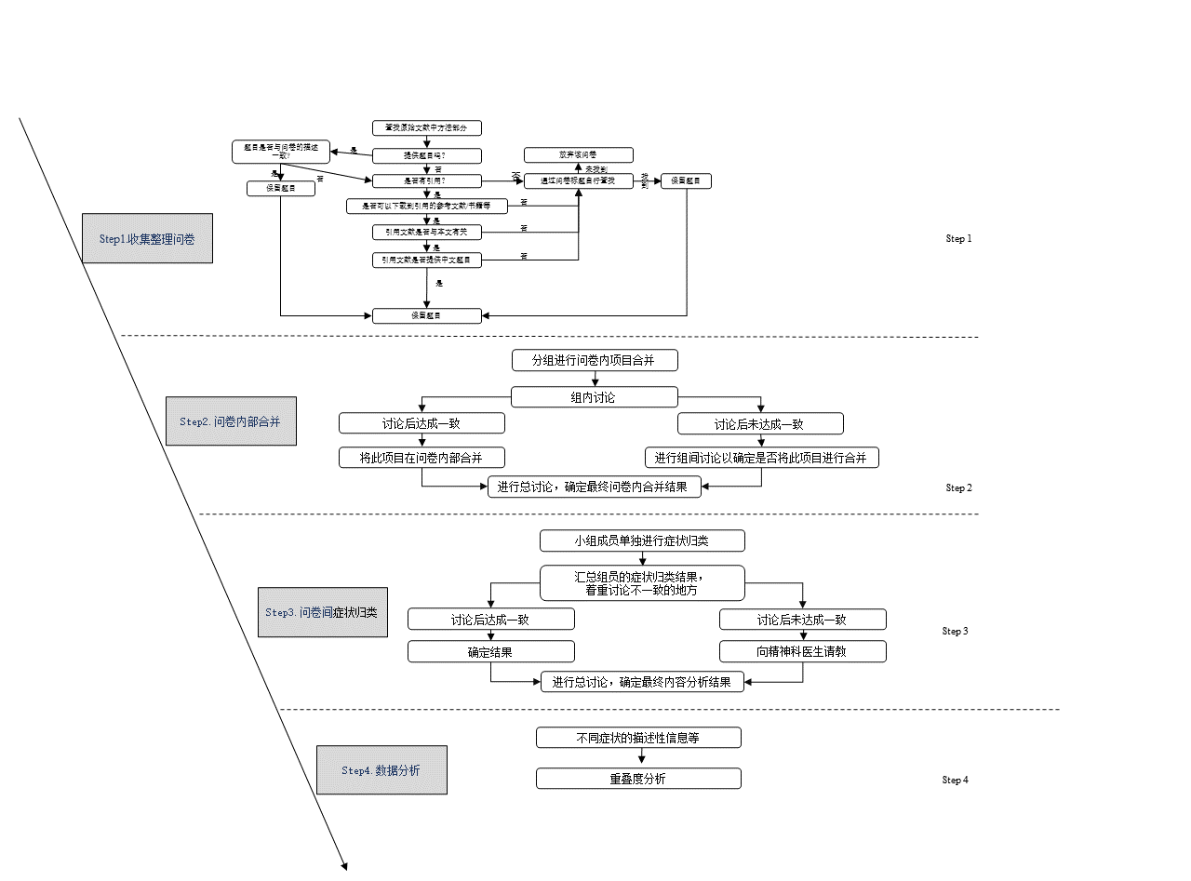

**Figure 1**

*Research flowchart*

# 3 Result

1基本情况

2问卷内 条目合并，症状特点

3问卷间 包括下面这四小点

1针对图的基本情况每个症状在不同量表中出现多少次，进一步的解释是有多少个症状是独特的

2针对图的进一步解释那些出现的最多

3那些症状是独特的

4重叠度

Github

最主要的库推到课题组的账号之下，每个人复制成分支

用github配置做一个网页

# 3.1 A summary of scales

In four meta-analyses, 470 papers were related to depression and 34 unique scales were identified. Among all these scales, the items of four scales, the Mini International Neuropsychiatric Interview for children and adolescents (Mini-KID), WHO-CIDI 3.0, Psychological Health Inventory (PHI), and the Symptom Checklist 45, were not available. The items of the other two scales, the Beck Depression Inventory (Zhang Yuxin Revised Edition) and Short Depression Scale, were not available either because of unidentifiable citations. These six scales were excluded from furthere analyses. The items used in 'Gu & Chen (2020) 'and 'Ji (2007)' were identifical but in different languages, thus we regarded these two studies used the same scale referred them as 'Ji (2007)'. Also, the boys’ and girls’ version of the Child Behavior Checklist (CBCL) were treated as one scale, CBCL. In short, 27 scales were included in the analysis. See figure 2 for the number of usages of these scales among all 470 empirical papers in the meta-analyes (CITATIONS). The seven most frequently used scales in this study are SDS, SCL-90, CES-D, CDI, DSRSC, BDI-I, and MSSMHS, among which CES-D and SDS are consistent with the scales selected by Fried (2017).

# 3.2 Items and symptoms within scales

For the 27 scales included, there are 425 items in total. We merged 73 items into 31 symptoms when coding items within scales. Alos, there were two cases where one item measured two symptoms. The item from Ji (2007), "During the past 12 months, did you ever feel so sad or hopeless almost every day for two weeks or more in a row that you stopped doing your usual activities?" meausres both 'sad' and 'Sense of hopelessness'. And the 8th item from PHQ-9, "Actions or speech slowed down to a noticeable extent, or conversely—feeling restless or agitated, being unable to sit still, more than usual", measures both 'Agitation' and 'Retardation'. Thus, a total of 385 symptoms were identified across different scales (See Table 1 for number of items and symptoms of each included scale).

放到补充材料

**Table1** *Combined results of items in the scale*

|  |  |  |  |  |
| --- | --- | --- | --- | --- |
| Scale | Number of items before combining | Number of symptoms after combining | Item | Symptoms after combining |
| SDS | 20 | 19 | Q17: I feel like I'm a useful person, and someone needs me. & Q19: I believe that if I were to die, others might be better off. | Worthlessness |
| SCL-90 | 13 | 12 | Q14: Feel your energy levels drop and your activities slow down. & Q71: It's hard to do anything. | Energy loss |
| CES-D | 20 | 17 | Q3: I feel down, even with the help of family and friends. & Q6: I feel down. | Low mood |
|  | 20 | 17 | Q12: I feel happy. & Q16: I have a happy life. | Anhedonia |
|  | 20 | 17 | Q7: I find it hard to do everything. & Q20: I lack the motivation to do things. | Energy loss |
| CDI | 27 | 24 | Q7: Self-hatred. & Q3: Self-depreciation. & Q24: Self-depreciation (compared to peers). | Psychological inferiority |
|  | 27 | 24 | Q15: Learning difficulties & Q23: Underachieve. | Learning difficulties |
| DSRSC | 18 | 16 | Q2: Enjoyed a very sound sleep. & Q14: Have a nightmare. | Poor sleep |
| DSRSC | 18 | 16 | Q10: Life is boring & Q12: Like a variety of things | Interest/ Pleasure loss |
| BDI-I | 21 | 19 | Q2: 0, I'm not pessimistic about the future. 1, I feel pessimistic about the future. 2, I feel like I have nothing to look forward to. 3, I feel that the future is hopeless and nothing can get better. & Q3: 0, I don't look like a loser. 1, I think I fail more often than the average person. 2, When I look back on the past I see many failures. 3, I feel that I am a complete failure. | Sense of hopelessness |
|  | 21 | 19 | Q5: 0, I don't have a strong sense of guilt. 1, I feel guilty about many things I have done or should have done but didn't. 2, I feel guilty most of the time. 3, I feel guilty at any time. & Q8: 0, I don't blame or criticize myself any more than I did in the past. 1, I blame myself more than I used to. 2, Whenever I am at fault, I blame myself. 3, Whenever something bad happens, I blame myself. | Guilty/Self-accusation |
| BDI-II | 21 | 20 | Q5: Guilty & Q8: Self-accusation | Guilty/Self-accusation |
| CBCL_BOY | 17 | 16 | Q18: Intentionally harming oneself or attempting suicide. & Q91：Expressing the intention to commit suicide. | Suicidal ideation |
| CBCL_GIRL | 18 | 17 | Q12: Often talk about feeling lonely. & Q111: Lonely and unsociable. | Feeling Lonely |
| MFQ-C | 33 | 26 | Q7: Feeling uneasy. & Q22: Crap happens. | Psychic anxiety |
|  | 33 | 26 | Q6: Slower than usual in activities. & Q13: Speaking slower than usual. | Retardation |
|  | 33 | 26 | Q16: Life is not worth living. & Q17：Thinking about death. & Q19：Thinking of suicide. | Suicidal ideation |
|  | 33 | 26 | Q8: No longer a good person. & Q9: Feeling self-blame for things that aren't my fault. & Q24: Considering oneself a bad person. & Q31: It's wrong to do anything. | Guilty/Self-accusation |
| CSSDS | 20 | 14 | Q2: I have low energy. & Q14: I take everything as a burden. | Energy loss |
|  | 20 | 14 | Q4: I have no interest in studying. & Q8: I find studying dull and uninteresting. & Q12: My grades are dropping. & Q16： I worry about my academic performance. & Q18: I lost the will to study. & Q20: My study efficiency is low. | Learning difficulties |
| CES-D-C | 20 | 16 | Q8: Was not happy & Q9: Felt down and unhappy. Q17: Was happy(R). & Q18: Had a good time. | Anhedonia |
|  | 20 | 16 | Q16: Something good going to happen & Q10: Things did not work out. | Sense of hopelessness |
| ADI | 31 | 29 | Q4: I feel sorry for others. & Q9: Nothing I do is going to make me better. | Guilty/Self-accusation |
|  | 31 | 29 | Q8: I can't pay attention in class. & Q16: I feel like I can't concentrate. | Concentration |
| CES-D-13 | 13 | 10 | Q2: Feel down. & Q4: Feel down. | Low mood |
|  | 13 | 10 | Q9: Feel happy. & Q11: Happy life. | Anhedonia |
|  | 13 | 10 | Q5: Work hard. & Q13: Can't get up. | Energy loss |
| HADS | 7 | 4 | Q4: I can laugh heartily and see the positive side of things. & Q12: I seem to be feeling my emotions gradually declining. | Low mood |
|  | 7 | 4 | Q2: I still have an interest in things I used to be interested in. & Q8: I have lost interest in my appearance (dressing up). & Q14: I can appreciate a good book or a quality radio or television program. | Interest loss |
| SMFQ | 13 | 12 | Q9: Feeling like a bad person. & Q13: Feeling like I've done everything wrong. | Guilty/Self-accusation |
| UPI | 12 | 11 | Q9: Lack of confidence & Q10: Feeling self-abased | Self-abased |

*Note.* Most of the items have been translated from the Chinese version into English, which may result in differences in meaning from the original English version.

移到补充材料，3.2和3.3合并

# 3.3 Symptoms across scales

The comparison of 385 symptoms across 27 scales resulted in unique 84 symptoms (see Figure 3). Among these, eight are compound symptoms, including *Depressive mood, Irritability*, *Self-abasement*, *Interest/pleasure loss*, *Somatization*, *Appetite changes*, *Somnipathy*, and *Reduced socialization* (see Table 2).

**Table2**

*Compound symptoms and the specific symptoms they contain*移到补充材料

|  |  |
| --- | --- |
| Compound symptoms | Specific symptoms |
| Depressive mood | Blue, Low mood, Sad, Anhedonia |
| Irritability | Prone to anger towards parents |
| Self-abasement | Psychological inferiority, Negative body perception |
| Interest/pleasure loss | Interest loss, Pleasure loss |
| Somatization | Gastrointestinal, Sympathetic arousal, General somatic symptoms |
| Appetite changes | Appetite increase, Appetite decrease |
| Somnipathy | Poor sleep, Hypersomnia, Early insomnia, Middle insomnia, Late insomnia |
| Reduced socialization | I didn’t want to see my friends. |

The most frequently measured symptom, appeared in 22 out of 27, was *Sense of hopelessness*. The second most measured symptom, 18 out of 27, was Interest loss. Note that anhedonia, a key symptom of major depression, is separated into two symptoms, loss of interest and loss of pleasure, in DSM-5. We found *loss of pleasure* was observed less frequently than *loss of interest*, being measured in 9 out of 27 scales.

3.3跨文卷比较

1针对图的基本情况每个症状在不同量表中出现多少次，进一步的解释是有多少个症状是独特的

2针对图的进一步解释那些出现的最多

3那些症状是独特的

4重叠度

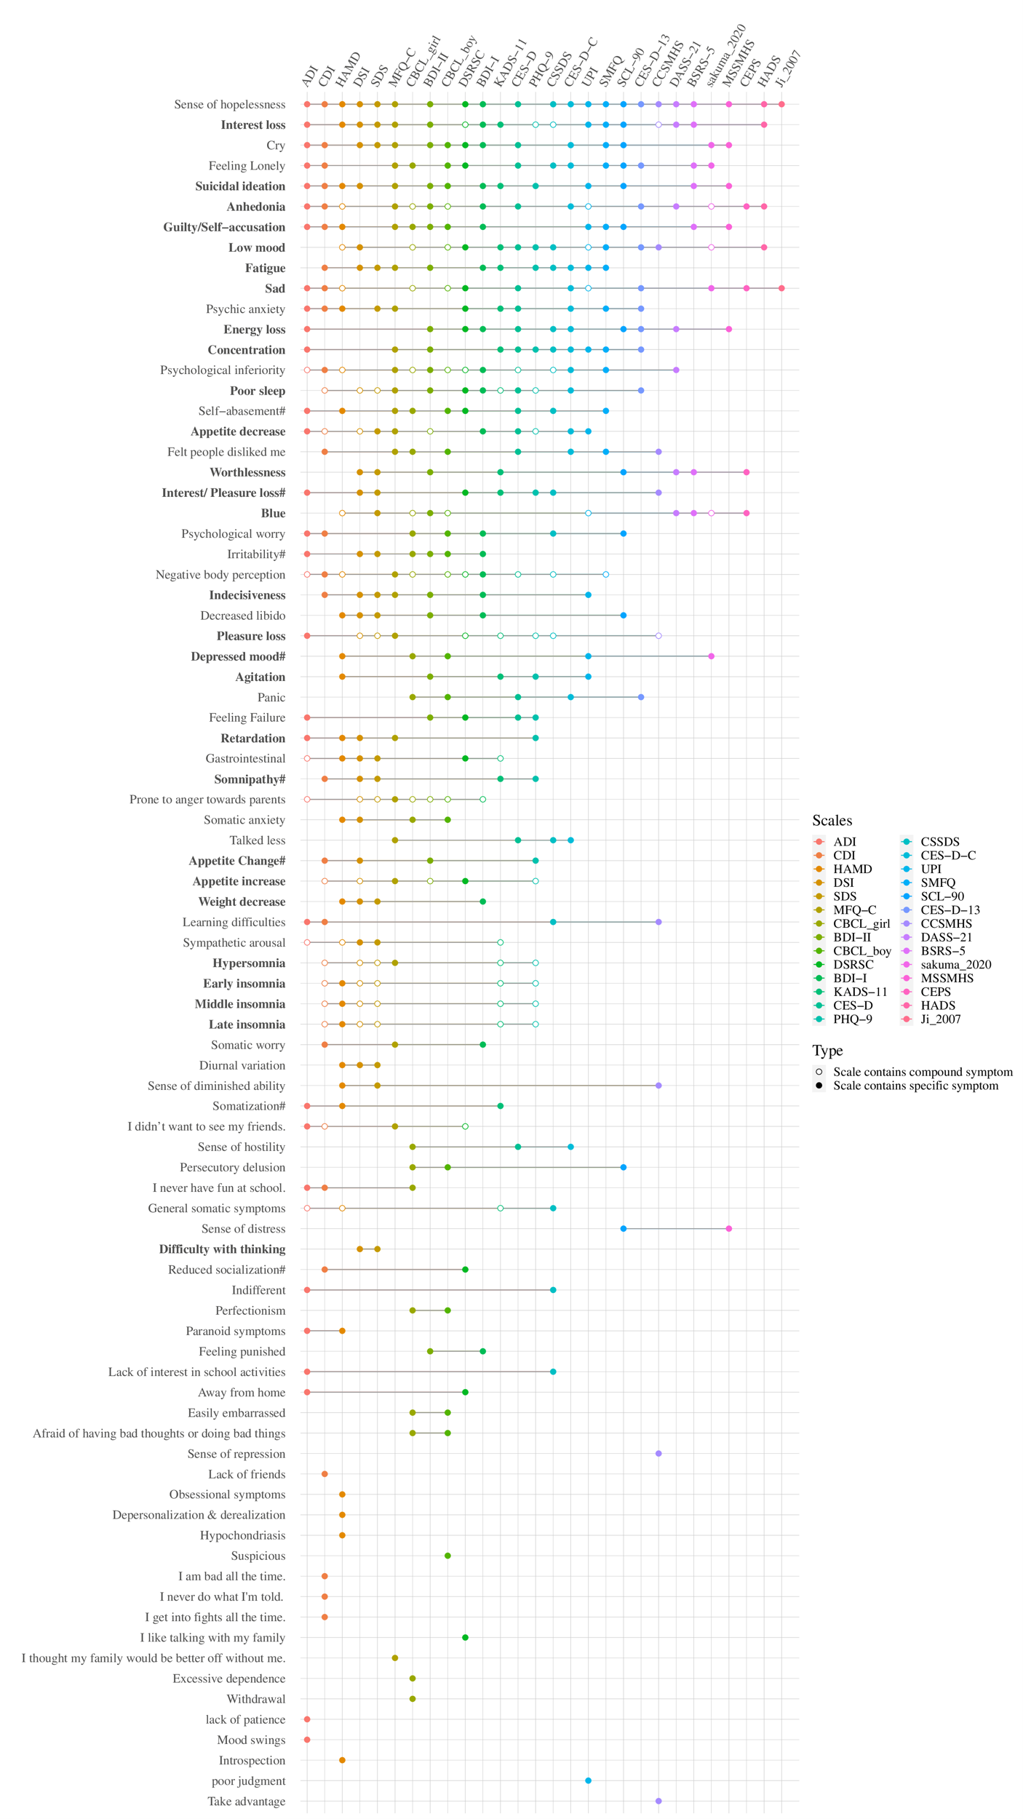

**Figure 3***. Content Overlap Across* *Twenty-seven Depression Scales.* Each row represents a symptom, each column represents a scale.If a scale measures a symptom, then there is a dot or a circle on that row. The former represent compound symptoms and the latter represent specific symptoms. Symptoms in bold font are from DSM-5. ADI: Adolescent Depression Inventory, CDI: Children's Depression Inventory, HAMD: Hamilton Depression Rating Scale for Depression, DSI: Depression Status Inventory, SDS: Self- Rating Depression Scale, MFQ-C: Mood and Feelings Questionnaire, CBCL: Child Behavior Checklist, BDI-II：Beck Depression Inventory-II, DSRSC: Depression Self-rating Scale for Children, BDI-I: Beck Depression Inventory, KADS-11: Kutcher Adolescent Depression Scale, CES-D: The Center for Epidemiological Studies Depression Scale, PHQ-9: Patient Health Questionnaire-9 items, CSSDS: China Middle school students' depression scale, CES-D-C: Center for Epidemiologic Studies Depression Scale for Children, UPI: University Personality Inventory, SMFQ: Short Mood and Feelings Questionnaire, SCL-90: Symptom Checklist 90, CES-D-13: Short version of Center for Epidemiologic Studies Depression Scale, CCSMHS: Chinese College Student Mental Health Scale, DASS-21: The Depression Anxiety Stress Scale, BSRS-5: Brief Symptom Rating Scale, Sakuma_2010: Sakuma et al.(2010) self-designed questionnaire, MSSMHS: Middle-school students Mental Health Scale, CEPS: China Education Panel Survey, HADS: Hospital Anxiety and Depression Scale, Ji_2007: Comprehensive Survey Report on Health-Related/Risk Behaviors among Chinese Adolescents.

*Depressed mood* is not the most commonly measured symptom across scales because, as mentioned earlier, we retained several symptom descriptions related to depressive mood, including a compound symptom of *depressed mood*, and specific symptoms of *blue*, *low mood*, *sad*,and *anhedonia*. The compound symptom *Depressed mood* was measured by 5 scales, the specific symptom *blue* was measured by 10 scales, *low mood* by 15 scales, *sad* by 13 scales, *anhedonia by 16 scales.* If these symptoms were combined with *depressed mood*, this symptom would be the most frequent symptom among the 25 scales. Figure 4 lists in how many scales each of the symptoms are listed; for instance, 11 of the 84 symptoms (13.10%) appear across a subset of 2 scales. Among the 84 symptoms, 18 (21.43%) were idiosyncratic symptoms and only appeared in one scale. None of the symptoms were present on all scales.

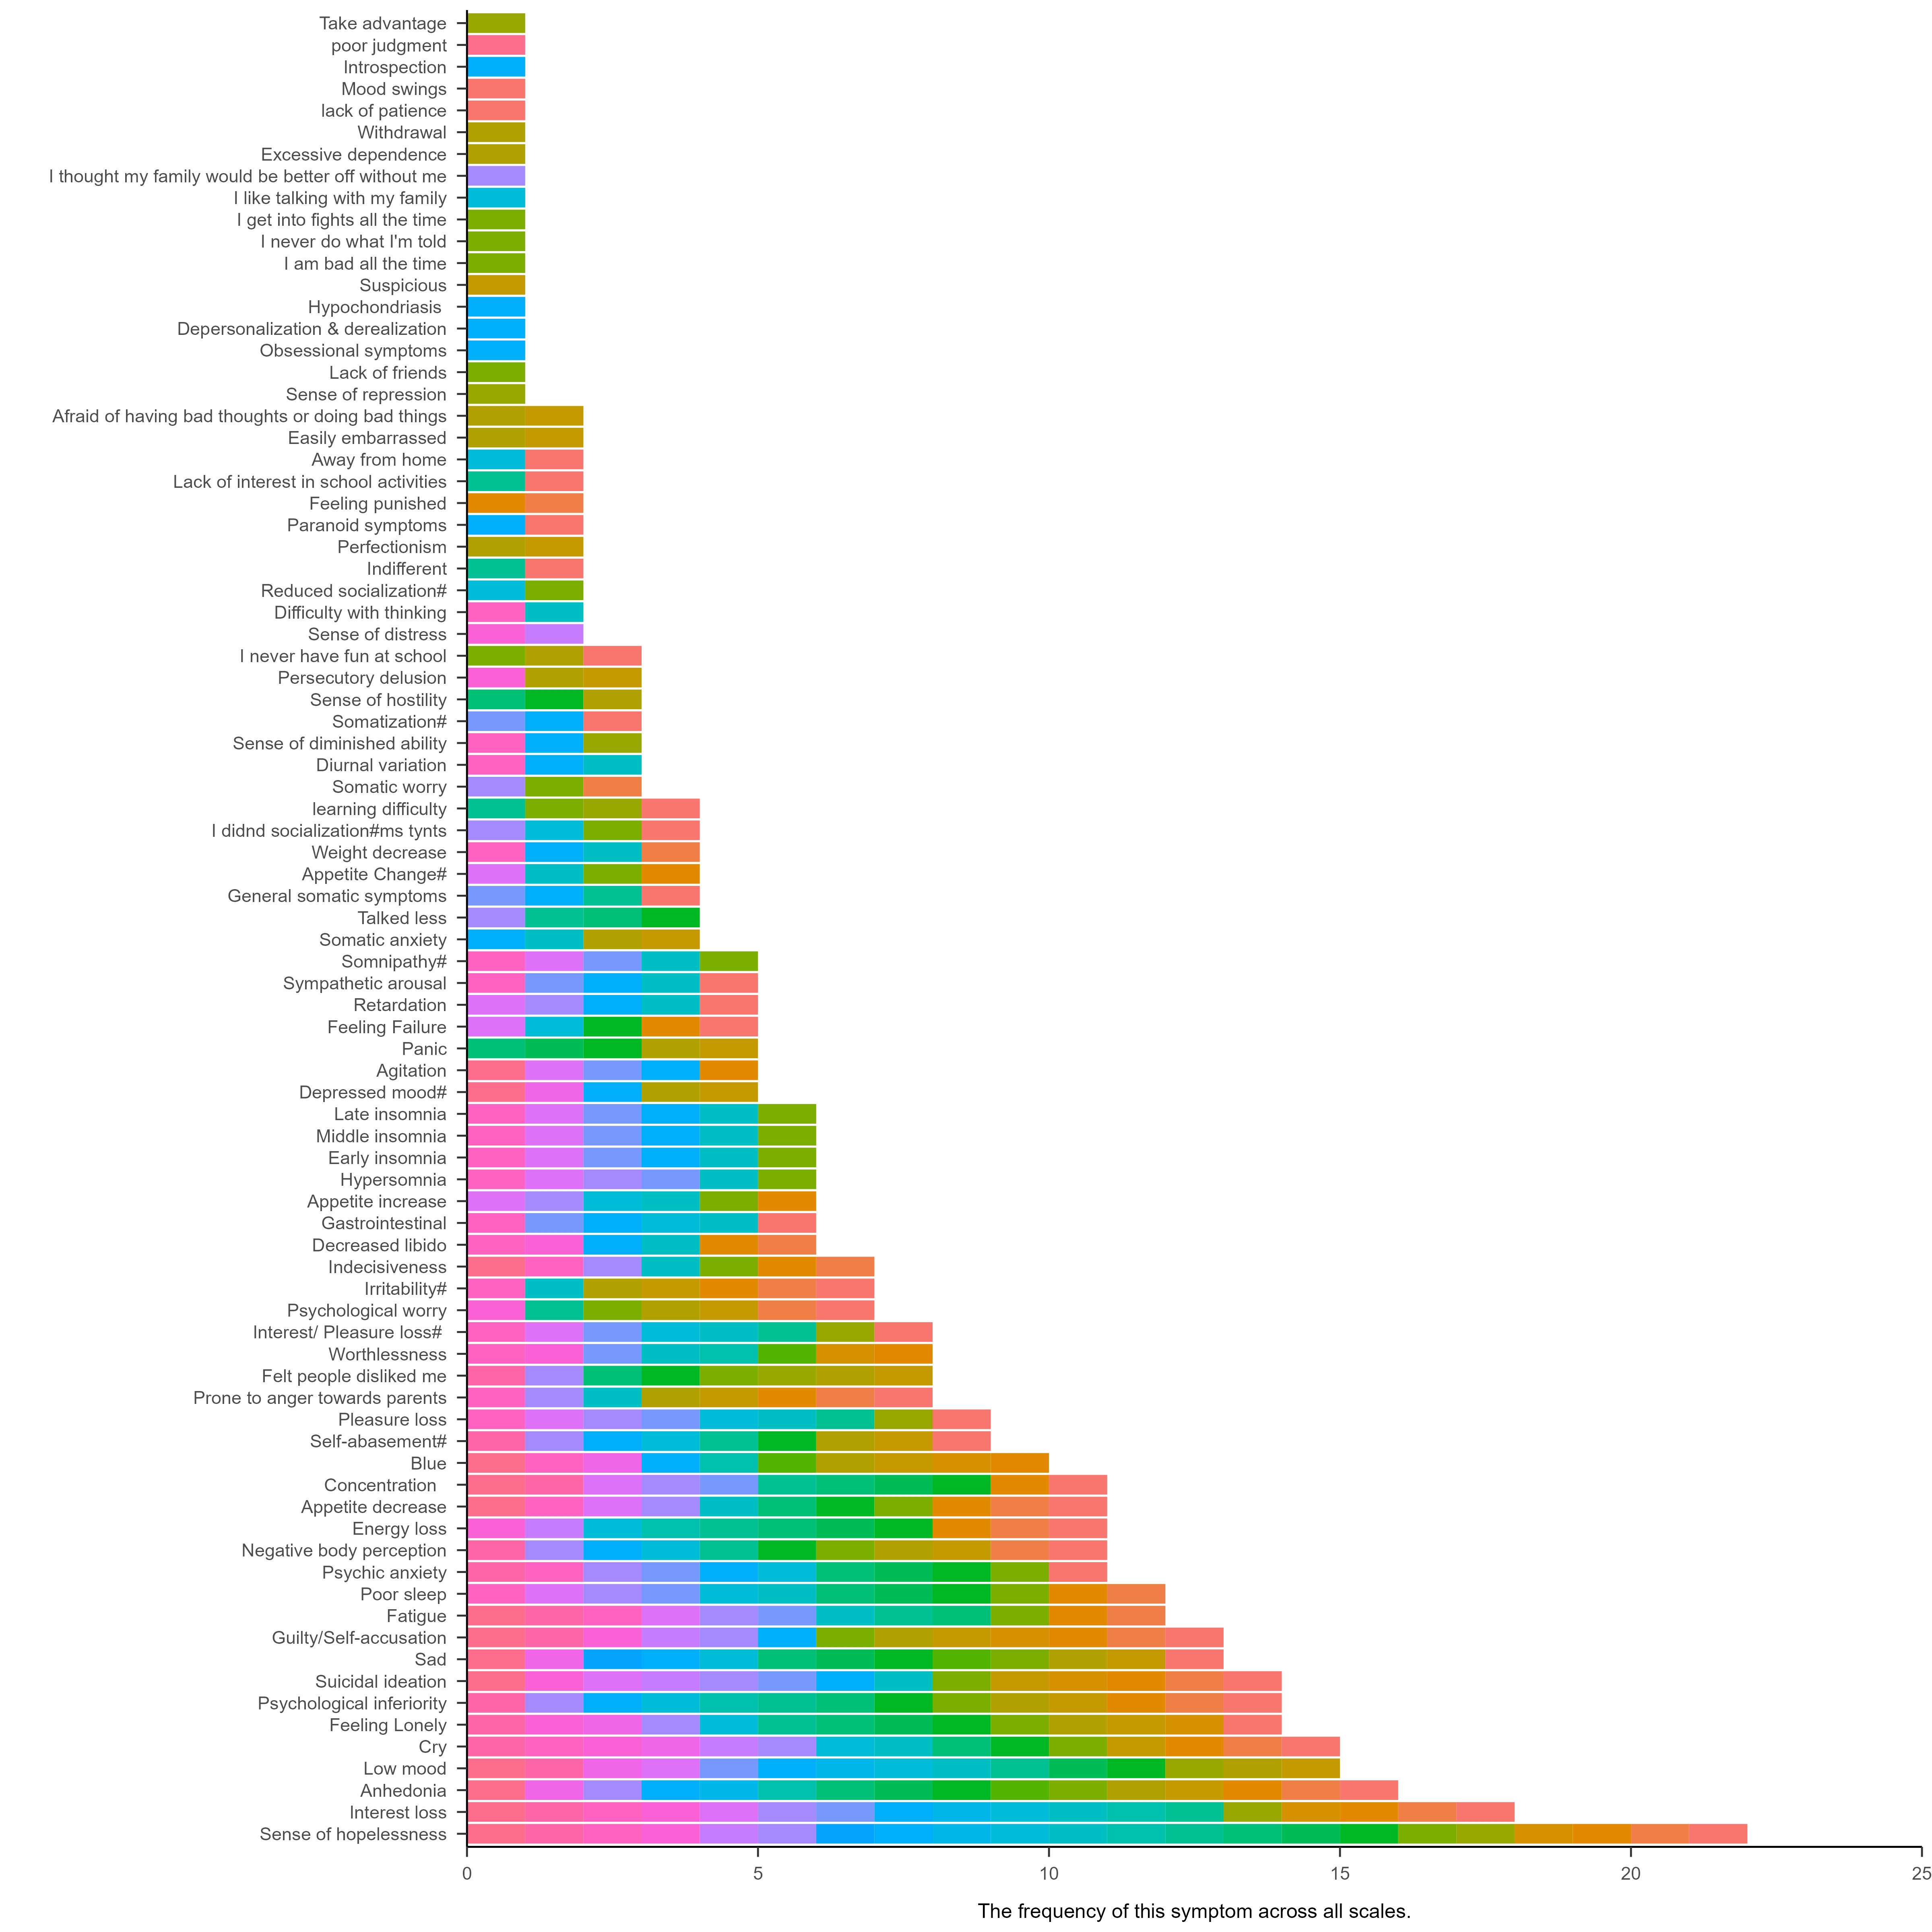

**Figure 4 症状多的放在上面，黑白色就可以了**

*Number of symptoms that appear across combinations of scales.* There are 18 symptoms that appear only in one scale; these symptoms are referred to as idiosyncratic symptoms.

We comprehensively reported the number of symptoms included in each inventory, the adjusted scale length, the number of idiosyncratic symptoms and the ratios of compound and specific symptoms. Furthermore, it outlines the prevalence of DSM-5 depressive symptoms within each scale. Among the scales analyzed, 19 did not include any idiosyncratic symptoms. The CSSMHS exhibited the highest percentage of idiosyncratic symptoms, with a prevalence of 22.22%, while the remaining scales showed varying rates of idiosyncratic symptom inclusion, ranging from 3.85% to 12.5%. Ten scales did not incorporate compound symptoms, with proportions for the remaining scales varying from 7.69% to 47.37%. The DSI exhibited the highest prevalence of DSM-5 depression symptoms, encompassing 71.42% of the total nine DSM-5 depression symptoms. Conversely, the Ji_2005 scale demonstrated the lowest representation, comprising only 3.57% of the nine DSM-5 depression symptoms. It is also the least number of items among the scales included in this study. The supplementary materials provide detailed information.

# 3.4 Overlap between scales

The degree of overlap between scales was calculated using the Jaccard coefficient. The mean overlap across all scales was 0.19 (0.09 ~ 0.25), indicating a very low level of similarity between these scales. For the specific degree of overlap between each pair of scales and the average overlap with other scales, refer to Figure 5. CES-D has the highest average degree of overlap with other scale, at 0.25. The two scales with the highest overlap were CES-D and CES-D-C at 0.75, followed by DSI and SDS at 0.72. Many scales that have no overlap with each other. For example, there was no overlap between China Education Panel Survey with Middle-school students Mental Health Scale, PHQ-9, CSSDS, SMFQ, CSSMHS. Note that because Ji_2005 has only one item that measures two symptoms, it has no overlap with PHQ-9, KADS-11.

We found a correlation between the mean overlap of scales and the scale length, *r* = 0.57, 95% CI [0.29-0.74]. Similarly, the correlation between mean overlap of scales and the number of captured symptoms is *r* = 0.69, 95% CI [0.48-0.82]. These findings suggests that longer scales exhibit increased overlap with other scales, thus demonstrating enhanced representativeness.

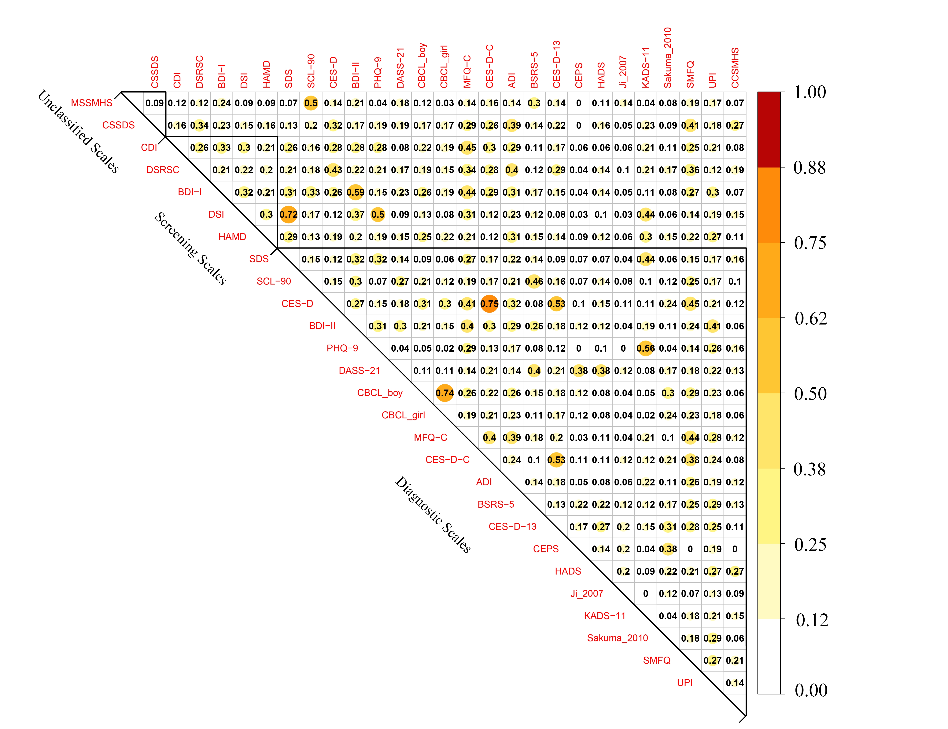

**Figure 5 在图里解释下**

*Overlap of item content of 27 depression scales.* ADI: Adolescent Depression Inventory, CDI: Children's Depression Inventory, HAMD: Hamilton Depression Rating Scale for Depression, DSI: Depression Status Inventory, SDS: Self- Rating Depression Scale, MFQ-C: Mood and Feelings Questionnaire, CBCL: Child Behavior Checklist, BDI-II：Beck Depression Inventory-II, DSRSC: Depression Self-rating Scale for Children, BDI-I: Beck Depression Inventory, KADS-11: Kutcher Adolescent Depression Scale, CES-D: The Center for Epidemiological Studies Depression Scale, PHQ-9: Patient Health Questionnaire-9 items, CSSDS: China Middle school students' depression scale, CES-D-C: Center for Epidemiologic Studies Depression Scale for Children, UPI: University Personality Inventory, SMFQ: Short Mood and Feelings Questionnaire, SCL-90: Symptom Checklist 90, CES-D-13: Short version of Center for Epidemiologic Studies Depression Scale, CCSMHS: Chinese College Student Mental Health Scale, DASS-21: The Depression Anxiety Stress Scale, BSRS-5: Brief Symptom Rating Scale, Sakuma_2010: Sakuma et al.(2010) self-designed questionnaire, MSSMHS: Middle-school students Mental Health Scale, CEPS: China Education Panel Survey, HADS: Hospital Anxiety and Depression Scale, Ji_2007: Comprehensive Survey Report on Health-Related/Risk Behaviors among Chinese Adolescents. Mean overlap is detailed in the supplementary materials.

# 4 讨论

[第一段的主旨句]

研究分析了多个常用的抑郁量表，并发现它们在捕捉抑郁症状方面存在较大的异质性。这些量表之间的项目内容重叠度较低。这对于使用和解释相关数据有重要的启示作用。

[第二段的主旨句]

Fried (2017).的研究中Ces-d与其他量表有着最差的平均重叠率（0.27），而Ces-d在本研究中表现出最高的平均重叠率（0.25），可能是由于：1、本研究中除Ces-d以外还纳入了Ces-d简版以及Ces-d儿童版。2、在他的研究中Ces-d有33%的独特症状，而本研究中，随着纳入的量表增加，Ces-d的独特症状为0。

[第三段的主旨句]

抑郁量表的异质性来源可能是由于构念的不清晰，因此，在合并来自不同量表的研究结果时（例如元分析），特别是那些几乎没有重叠的量表时，可能不明智。

[第四段的主旨句]

不能认为低重叠就是糟糕的量表，高重叠就是好的量表。选择测量工具时应考虑多种因素，并根据评估的目的和目标进行选择。

[第五段的主旨句]

目前仍普遍认为量表可以互相替代，研究结果表明量表之间异质性非常强。因此在推广结果中应该强调这是某个量表的结果。

[第六段的主旨句]

确定哪些量表是合适的量表非常重要，我们团队正在使用cosmin系统对本次研究中涉及的量表进行评估。

**参 考 文 献**

于晓琪, 张亚利, 俞国良. (2022). 2010～2020中国内地高中生心理健康问题检出率的元分析. *心理科学进展*, *30*(05), 978-990.

黄潇潇, 张亚利, 俞国良. (2022). 2010～2020中国内地小学生心理健康问题检出率的元分析. *心理科学进展*, *30*(05), 953-964.

张亚利, 靳娟娟, 俞国良. (2022). 2010～2020中国内地初中生心理健康问题检出率的元分析. *心理科学进展*, *30*(05), 965-977.

陈雨濛, 张亚利, 俞国良. (2022). 2010～2020中国内地大学生心理健康问题检出率的元分析. *心理科学进展*, *30*(05), 991-1004.

汪向东等. (1999). *心理卫生评定量表手册*. 中国心理卫生杂志社.

章婕, 吴振云, 方格, 李娟, 韩布新, 陈祉妍. (2010). 流调中心抑郁量表全国城市常模的建立. *中国心理卫生杂志*, *24*(02), 139-143.

Gu, J., & Chen, S. (2020). Association between active travel to school and depressive symptoms among early adolescents. *Children*, *7*(5), 41.

季成叶. (2007). *中国青少年健康相关/危险行为调查综合报告-2005*. 北京大学医学出版社.

张明园. (1998). *精神科评定量表手册*. 湖南科学技术出版社.

陈姜, 张德甫, 吴敏, 胡巧云, 徐俊娥, 付喜成. (2000). 中学生焦虑情绪调查. *中国校医*(04), 257-258.

Jordan, K. M., Ayers, P. M., Jahn, S. C., Taylor, K. K., Huang, C., Richman, J., & Jason, L. A. (2000). Prevalence of fatigue and chronic fatigue syndrome-like illness in children and adolescents. *Journal of Chronic Fatigue Syndrome*, *6*(1), 3-21.

王汝展, 刘兰芬, 葛红敏, 韩建波. (2009). ZUNG氏抑郁自评量表(SDS)作为外科住院患者抑郁障碍常规筛查工具的可行性研究. *精神医学杂志*, *22*(04), 251-253.

Zung, W. W. (1965). A self-rating depression scale. *Archives of General Psychiatry*, *12*(1), 63-70.

任艳峰, 翟强, 王素珍. (2015). 初中生睡眠质量与肥胖的相关性分析. *中国学校卫生*, *36*(09), 1316-1318.

苏春燕, 张洪君, 王宜芝. (2003). 癌症末期病人家属感受和需求的调查. *护理研究*(09), 519-520.

张作记. (2005). *行为医学量表手册*. 行为医学量表手册.

姚树桥, 孙学礼. (2008). *医学心理学.第5版*. 医学心理学.第5版.

戴晓阳. (2010). *常用心理评估量表手册*. 人民军医出版社.

王俊, 金岳龙, 陈燕, 余结根, 贺连平, 姚应水. (2013). 医学院校大学生抑郁情绪与生活事件的相关分析. *皖南医学院学报*, *32*(02), 151-153.

崔庆霞, 王在翔. (2014). 大学生抑郁现状调查及影响因素研究. *中国卫生事业管理*, *31*(08), 629-630.

段泉泉, 胜利. (2012). 焦虑及抑郁自评量表的临床效度. *中国心理卫生杂志*, *26*(09), 676-679.

郑世华, 仝巧云, 郑爱军. (2016). 大学生抑郁和焦虑状况调查及相关因素分析. *重庆医学*, *45*(20), 2835-2837.

王征宇, 迟玉芬. (1984). 抑郁自评量表(SDS). *上海精神医学*(02), 71-72.

张明园等. (2015). *精神科评定量表手册*. 湖南科学技术出版社.

Zung, W. W. (1969). A cross-cultural survey of symptoms in depression. *American Journal of Psychiatry*, *126*(1), 116-121.

崔杰诚, 陈国生. (1998). 《心理卫生与精神科评定量表》专辑. *健康心理学杂志*, *６*(10), 140-141.

戴海崎, 张锋, 陈雪枫. (2007). *心理与教育测量: 修订版*. 广州: 暨南大学出版社.

仲稳山. (2009). *心理诊断学*. 苏州: 苏州大学出版社.

王征宇. (1984). 症状自评量表(SCL-90). *上海精神医学*(02), 68-70.

高成阁, 王友平, 亢万虎, 张西生, 李强, 方明,... 何瑞嫦. (1997). 陕西省大中学生心理健康水平调查. *中国临床心理学杂志*(01), 42-43.

Derogatis, L. R., Rickels, K., & Rock, A. F. (1976). The SCL-90 and the MMPI: A step in the validation of a new self-report scale. *The British Journal of Psychiatry*, *128*(3), 280-289.

陈树林, 李凌江. (2003). SCL-90信度效度检验和常模的再比较. *中国神经精神疾病杂志*(05), 323-327.

黄赐英, 裴利华. (2005). 大学新生SCL—90调查结果与分析. *株洲师范高等专科学校学报*(03), 29-32.

陈国鹏. (2005). *心理测验与常用量表*. 上海: 上海科学普及出版社.

Mensah, F. K., & Kiernan, K. E. (2010). Parents’ mental health and children’s cognitive and social development: families in England in the Millennium Cohort Study. *Social Psychiatry and Psychiatric Epidemiology*, *45*, 1023-1035.

金华, 吴文源, 张明园. (1986). 中国正常人SCL-90评定结果的初步分析. *中国神经精神疾病杂志*(05), 260-263.

Derogatis, L. R. (1973). SCL-90: an outpatient psychiatric rating scale-preliminary report. *Psychopharmacol Bull*, *9*, 13-28.

Derogatis, L. R. (1977). *The SCL‐90: Administration, Scoring and Procedures Manual*. Baltimore, MD, USA: John Hopkins University Press.

Hoffmann, N. G., & Overall, P. B. (1978). Factor structure of the SCL-90 in a psychiatric population. *Journal of Consulting and Clinical Psychology*, *46*(6), 1187.

史从戎, 张曼华, 王宇, 来源, 高保兴, 乔晓春. (2011). 我国部分农村地区受艾滋病影响儿童心理弹性的保护性因素研究. *中国儿童保健杂志*, *19*(01), 10-12.

Radloff, L. S. (1991). The use of the Center for Epidemiologic Studies Depression Scale in adolescents and young adults. *Journal of Youth and Adolescence*, *20*(2), 149-166.

Cheng, C., Yen, C., Ko, C., & Yen, J. (2012). Factor structure of the center for epidemiologic studies depression scale in Taiwanese adolescents. *Comprehensive Psychiatry*, *53*(3), 299-307.

Lee, S. W., Stewart, S. M., Byrne, B. M., Wong, J. P., Ho, S. Y., Lee, P. W., & Lam, T. H. (2008). Factor structure of the Center for Epidemiological Studies Depression scale in Hong Kong adolescents. *Journal of Personality Assessment*, *90*(2), 175-184.

Cheung, C., & Bagley, C. (1998). Validating an American scale in Hong Kong: the center for epidemiological studies depression scale (CES-D). *The Journal of Psychology*, *132*(2), 169-186.

陈祉妍, 杨小冬, 李新影. (2009). 流调中心抑郁量表在我国青少年中的试用. *中国临床心理学杂志*, *17*(04), 443-445.

Wang, M., Armour, C., Wu, Y., Ren, F., Zhu, X., & Yao, S. (2013). Factor structure of the CES‐D and measurement invariance across gender in mainland Chinese adolescents. *Journal of Clinical Psychology*, *69*(9), 966-979.

Yang, L., Jia, C., & Qin, P. (2015). Reliability and validity of the Center for Epidemiologic Studies Depression Scale (CES-D) among suicide attempters and comparison residents in rural China. *BMC Psychiatry*, *15*(1), 1-8.

Radloff, L. S. (1977). The CES-D scale: A self-report depression scale for research in the general population. *Applied Psychological Measurement*, *1*(3), 385-401.

潘丝媛, 李武权, 黎明, 郭蓝, 邓雪清, 卢次勇. (2018). 广州市中学生网络成瘾与自杀相关行为的关系. *中国学校卫生*, *39*(02), 229-231.

Jiang, L., Wang, Y., Zhang, Y., Li, R., Wu, H., Li, C., ... Tao, Q. (2019). The reliability and validity of the center for epidemiologic studies depression scale (CES-D) for Chinese university students. *Frontiers in Psychiatry*, *10*, 315.

刘平. (1999). 流调中心用抑郁量表（Center for Epidemiological Studies Depression Scale，CES-D）. *中国心理卫生杂志（增刊）*, 200-202.

刘琰, 谭曦, 李扬, 徐芳, 张杰, 孔军辉. (2015). 大学生抑郁情绪现状及影响因素分析. *中华全科医学*, *13*(01), 91-93.

Kovacs, M. (1992). Children’s depression inventory. *Acta Paedopsychiatrica: International Journal of Child & Adolescent Psychiatry*.

Beck, A. T., Ward, C. H., Mendelson, M., Mock, J., & Erbaugh, J. (1961). An inventory for measuring depression. *Archives of General Psychiatry*, *4*(6), 561-571.

洪忻, 李解权, 梁亚琼, 王志勇, 徐斐. (2012). 儿童抑郁量表中文版在中学生中的信效度分析. *中国学校卫生*, *33*(10), 1182-1185.

陈海燕, 姚树桥, 明庆森, 侯婵娟. (2012). 中学生的抑郁症状与生活事件:非适应性策略的中介作用. *中国心理卫生杂志*, *26*(10), 786-790.

俞大维, 李旭. (2000). 儿童抑郁量表(CDI)在中国儿童中的初步运用. *中国心理卫生杂志*(04), 225-227.

吴文峰, 卢永彪, 谭芙蓉, 姚树桥. (2010). 儿童抑郁量表中文版在中小学生中的信效度. *中国心理卫生杂志*, *24*(10), 775-779.

Samm, A., Värnik, A., Tooding, L., Sisask, M., Kolves, K., & Von Knorring, A. (2008). Children’s depression inventory in Estonia: single items and factor structure by age and gender. *European Child & Adolescent Psychiatry*, *17*, 162-170.

Kovas, M. (1985). The Children's Depression Inventory (CDI). *Psychological Bulletin*, *21*, 995-998.

苏林雁, 王凯, 朱焱, 罗学荣, 杨志伟, 儿童抑郁量表全国协作组. (2003). 儿童抑郁障碍自评量表的中国城市常模. *中国心理卫生杂志*(08), 547-549.

王凯, 苏林雁, 朱焱, 翟静, 杨志伟, 张纪水. (2002). 儿童焦虑性情绪障碍筛查表的中国城市常模. *中国临床心理学杂志*(04), 270-272.

周德新. (2006). 大学生自杀现象的社会学解读. *湖南文理学院学报(社会科学版)*(05), 60-62.

Beck, A. T., & Beck, R. W. (1972). Screening depressed patients in family practice. A rapid technic. *Postgrad Med*, *52*(6), 81-85. doi: 10.1080/00325481.1972.11713319

Beck, A. T., Steer, R. A., & Carbin, M. G. (1988). Psychometric properties of the Beck Depression Inventory: Twenty-five years of evaluation. *Clinical Psychology Review*, *8*(1), 77-100.

Beck, A. T., & Beamesderfer, A. (1974). *Assessment of depression: the depression inventory.*: S. Karger.

王极盛, 李焰, 赫尔实. (1997). 中国中学生心理健康量表的编制及其标准化. *社会心理科学*(04), 17-22.

王极盛. (1998). *心灵时代*. 中国城市出版社.

杨文辉, 刘绍亮, 周烃, 彭芳, 刘细梅, 李莉,... 蚁金瑶. (2014). 贝克抑郁量表第2版中文版在青少年中的信效度. *中国临床心理学杂志*, *22*(02), 240-245.

王振, 苑成梅, 黄佳, 李则挚, 陈珏, 张海音,... 肖泽萍. (2011). 贝克抑郁量表第2版中文版在抑郁症患者中的信效度. *中国心理卫生杂志*, *25*(06), 476-480.

Wang, D., Ou, C., Chen, M., & Duan, N. (2009). Health-promoting lifestyles of university students in Mainland China. *BMC Public Health*, *9*(1), 1-9.

Dere, J., Watters, C. A., Yu, S. C., Bagby, R. M., Ryder, A. G., & Harkness, K. L. (2015). Cross-cultural examination of measurement invariance of the Beck Depression Inventory–II. *Psychological Assessment*, *27*(1), 68.

Spitzer, R. L., Kroenke, K., Williams, J. B., Patient, H. Q. P. C., & Patient, H. Q. P. C. (1999). Validation and utility of a self-report version of PRIME-MD: the PHQ primary care study. *Jama*, *282*(18), 1737-1744.

Kroenke, K., & Spitzer, R. L. (2002). The PHQ-9: a new depression diagnostic and severity measure. *Psychiatric Annals*, *32*(9), 509-515.

Sun, X. Y., Li, Y. X., Yu, C. Q., & Li, L. M. (2017). Reliability and validity of depression scales of Chinese version: a systematic review. *Zhonghua Liu Xing Bing Xue Za Zhi= Zhonghua Liuxingbingxue Zazhi*, *38*(1), 110-116.

苑新群. (2014). *大学生媒体多任务与心理健康的关系*. 首都师范大学.

Lovibond, P. F., & Lovibond, S. H. (1995). The structure of negative emotional states: Comparison of the Depression Anxiety Stress Scales (DASS) with the Beck Depression and Anxiety Inventories. *Behaviour Research and Therapy*, *33*(3), 335-343.

龚栩, 谢熹瑶, 徐蕊, 罗跃嘉. (2010). 抑郁-焦虑-压力量表简体中文版(DASS-21)在中国大学生中的测试报告. *中国临床心理学杂志*, *18*(04), 443-446.

苏林雁, 李雪荣, 罗学荣, 万国斌, 杨志伟. (1998). Achenbach儿童行为量表的再标准化及效度检验. *中国心理卫生杂志*(02), 4-6.

忻仁娥. (1994). Achenbach 儿童行为量表( 中国标准化). *上海精神医学*, *4*(1), 1-2.

Achenbach, T., & Edelbrock, C. (1987). *Manual for the Child Behavior Checklist*. Burlington: University of Vermont.

Wood, A., Kroll, L., Moore, A., & Harrington, R. (1995). Properties of the mood and feelings questionnaire in adolescent psychiatric outpatients: a research note. *Journal of Child Psychology and Psychiatry*, *36*(2), 327-334.

曹枫林, 苏林雁, 程培霞. (2009). 情绪问卷中文版用于中学生的信度和效度研究. *中国临床心理学杂志*, *17*(04), 440-442.

王极盛, 邱炳武, 赫尔实. (1997). 中学生抑郁量表的编制及其标准化. *社会心理科学*(3), 3.

William Li, H. C., Chung, O. K. J., & Ho, K. Y. (2010). Center for epidemiologic studies depression scale for children: psychometric testing of the Chinese version. *Journal of Advanced Nursing*, *66*(11), 2582-2591.

Huang, C. Y., & Hsu, W. Y. (2003). A study of developing an adolescent depression inventory. *Journal of Education Psychology*, *26*, 167-190.

楊雅惠. (2003). 依附,負向情緒調適預期和壓力因應對情緒經驗的影響歷程之探討:以大四學生的生涯抉擇壓力為例.

Lee, M., Lee, Y., Yen, L., Lin, M., & Lue, B. (1990). Reliability and validity of using a brief psychiatric symptom rating scale in clinical practice. *Journal of the Formosan Medical Association*, *89*(12), 1081-1087.

Li, L. W., Liu, J., Xu, H., & Zhang, Z. (2016). Understanding rural–urban differences in depressive symptoms among older adults in China. *Journal of Aging and Health*, *28*(2), 341-362.

张宝山, 李娟. (2011). 简版流调中心抑郁量表在全国成年人群中的信效度. *中国心理卫生杂志*, *25*(07), 506-511.

Ma, L., Gao, L., Chiu, D. T., Ding, Y., Wang, W., & Wang, Y. (2020). Depressive symptoms prevalence, associated family factors, and gender differences: a national cohort study of middle school students in China. *Journal of Affective Disorders*, *274*, 545-552.

Zigmond, A. S., & Snaith, R. P. (1983). The Hospital Anxiety and Depression Scale. *Acta Psychiatrica Scandinavica*, *67*(6), 361-370.

汤毓华, 张明园. (1984). 汉密顿抑郁量表(HAMD). *上海精神医学*(02), 61-64.

周慧鸣, 郝楠, 杜亚松, 刘艳玉, 隋雨彤, 王艳华,... KUTCHER Stanley. (2015). 中文版Kutcher青少年抑郁量表测评青少年样本的效度与信度. *中国心理卫生杂志*, *29*(06), 413-418.

Sakuma, K. K., Sun, P., Unger, J. B., & Johnson, C. A. (2010). Evaluating depressive symptom interactions on adolescent smoking prevention program mediators: A mediated moderation analysis. *Nicotine & Tobacco Research*, *12*(11), 1099-1107.

程培霞, 曹枫林, 苏林雁. (2009). 简化情绪量表中文版用于中学生的信度和效度. *中国心理卫生杂志*, *23*(01), 60-62.

Yu, L., & Cai, L. (2007). Review on the application of the University Personality Inventory in China and abroad. *Prof Circle*(53), 158-159.

Huang, Q., Li, Y., Huang, S., Qi, J., Shao, T., Chen, X., ... Cai, Y. (2020). Smartphone use and sleep quality in chinese college students: a preliminary study. Front Psychiatry 11: 1–7.

张华. (2021). *散打运动对大学生心理健康影响的教学实验研究*. 河北师范大学.

刘豫鑫, 刘津, 王玉凤. (2010). 简明儿童少年国际神经精神访谈(父母版)的信效度. *中国心理卫生杂志*, *24*(12), 921-925.

刘豫鑫, 刘津, 王玉凤. (2011). 简明儿童少年国际神经精神访谈儿童版的信效度. *中国心理卫生杂志*, *25*(01), 8-13.

Andresen, E. M., Malmgren, J. A., Carter, W. B., & Patrick, D. L. (1994). Screening for depression in well older adults: Evaluation of a short form of the CES-D. *American Journal of Preventive Medicine*, *10*(2), 77-84.

Kessler, R. C., & Stün, T. B. (2004). The World Mental Health (WMH) Survey Initiative version of the World Health Organization (WHO) CompoundInternational Diagnostic Interview (CIDI). *International Journal of Methods in Psychiatric Research*, *13*(2).

宋维真, 张建平. (1993). *心理健康测查表(PHI)使用指导书*

. 北京：中国科学院心理研究所.

Fried, E. I. (2017). The 52 symptoms of major depression: Lack of content overlap among seven common depression scales. *Journal of Affective Disorders*, *208*, 191-197.